https://www.hackerearth.com/problem/algorithm/digit-sum-4/
#include <stdio.h>
int main() {
int T;
// Read the number of test cases[span_2](start_span)[span_2](end_span)
scanf("%d", &T);
// Process each test case[span_3](start_span)[span_3](end_span)
while (T--) {
int N;
scanf("%d", &N);
// The last digit is the remainder when divided by 10
int last_digit = N % 10;
// Keep dividing by 10 to find the first digit
int first_digit = N;
while (first_digit >= 10) {
first_digit /= 10;
}
// Print the sum of the first and last digit[span_4](start_span)[span_4](end_span)
printf("%d\n", first_digit + last_digit);
}
return 0;}
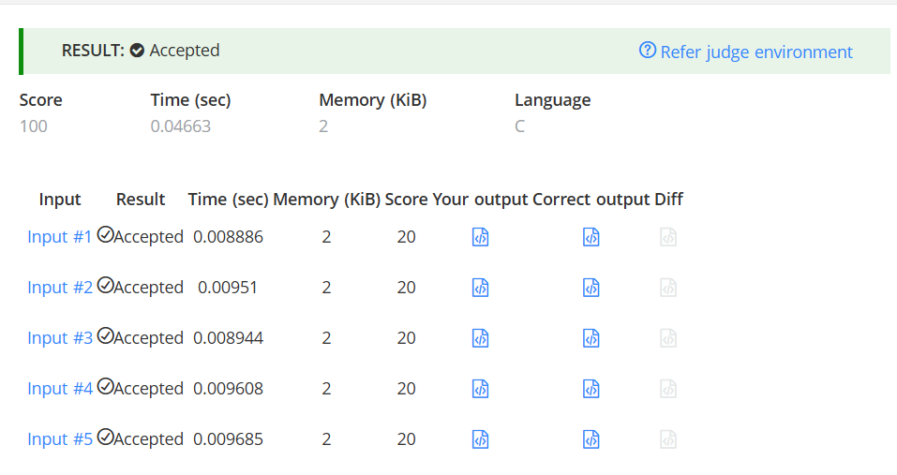n

